**PERCEPTO**

**SPHERE**

**Presented by:**

**Electronics and Communication Engineering**

**Proposal Report by**

**Amit Saha; 13001621073; 211300100310133; 4th year**

**Sayan Paul; 13000322120; 221300110656; 3rd year**

**Shinjan Saha; 13000322118; 221300110658; 3rd year**

**Shruti Sinha; 13000322112; 221300110664; 3rd year**

**Shantanu Saha; 13000721023; 211300100310139; 4th year**

**Under the guidance of**

**Dr. Moumita Sengupta**

**(Professor of ECE Department)**



**TECHNO MAIN SALT LAKE**

**EM 4/1 Salt Lake City, Sector – V Kolkata – 700091**

**2023**

**Table of Contents**

1. SYSTEM ARCHITECTURE
   1. PROJECT DETAILS
   2. WORK FLOW
2. INPUTS

2.1 SINGLE BOARD COMPUTER

2.2 CAMERA

2.3 SENSORS USED

1. OUTPUTS

3.1 SCREEN

3.2 SPEAKER

1. FUCNTIONS

4.1 IMAGE PROCESSING

4.2 OBJECT DETECTION

4.3 REAL TIME VIDEO CAPTURING

1. TEST CASES

5.1FOR PARTIALLY BLIND INDIVIDUALS

5.2 FOR COLOUR BLIND INDIVIDUALS

1. **SYSTEM ARCHITECTURE**
   1. **PROJECT DETAILS**

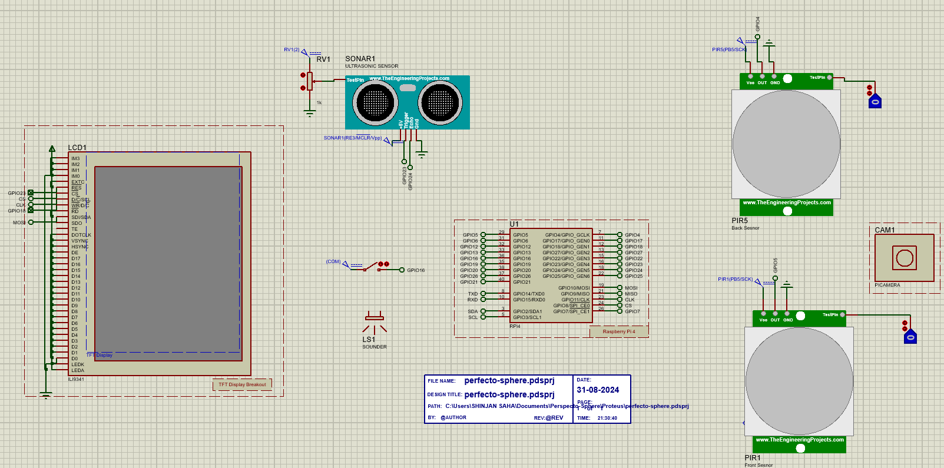

**Fig. System Architecture**

The "Percepto Sphere" project is an innovative solution aimed at enhancing the independence and mobility of visually impaired individuals.

The project involves developing a smart glass that leverages advanced object recognition technology using the YOLO (You Only Look Once) algorithm. This smart glass can identify objects in the user's surroundings and immediately provide an audio output, announcing the name of the detected object.

Additionally, the glass is equipped with distance measurement capabilities, allowing it to calculate the proximity of the object and convey this information to the user through an audio output. This technology aims to empower blind individuals by providing real-time, accurate information about their environment, significantly improving their ability to navigate and interact with the world around them.

In the following sections, we will navigate through the different functions that the Percepto Sphere can perform as well as look at test cases which can be applied with minor changes to the model to further enhance the multi-usage function of our design.

* 1. **WORK FLOW**

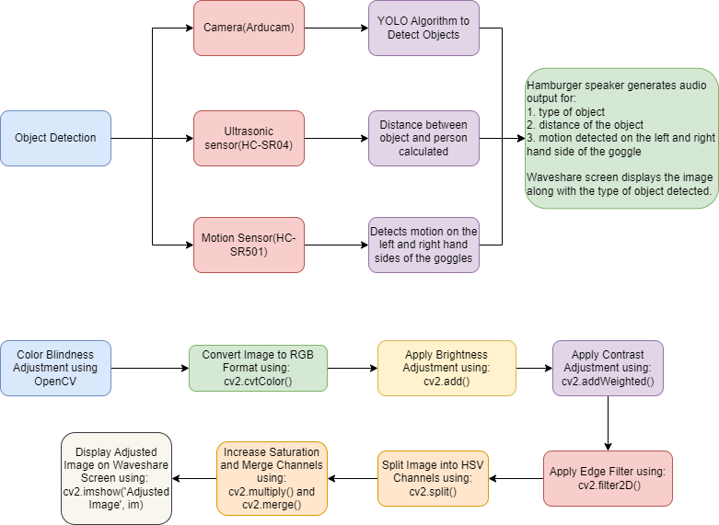

**Fig. Workflow of the system**

**Object Detection, Distance Calculation, and Motion Detection**

1. Camera Integration (Arducam): The Arducam, a small and lightweight camera module, serves as the visual "eyes" of the system. It is mounted on the glasses frame to capture a continuous feed of the scene in front of the user.
2. Object Detection (YOLO Algorithm): The camera feed is processed using the YOLO (You Only Look Once) algorithm. YOLO is renowned for its real-time performance, enabling the system to quickly identify and locate various objects within the scene, such as people, cars, and furniture.
3. Distance Measurement (Ultrasonic Sensor HC-SR04): An ultrasonic sensor emits sound waves and measures the time it takes for the echo to return. This data is used to calculate the distance between the user and nearby objects, providing spatial awareness and detecting obstacles in the user’s path.
4. Motion Detection (Motion Sensor HC-SR501): Motion sensors, placed on the sides of the glasses frame, monitor movement within their field of view. They alert the user to any potential hazards or objects approaching from the sides, enhancing situational awareness.

**Output**

1. Audio Output (Hamburger Speaker): A compact speaker provides audio feedback to the user. It communicates information about detected objects, their distances, and any motion detected on the sides, serving as the primary mode of interaction.
2. Visual Output (Waveshare Screen): The Waveshare screen has a dual role:
   * Camera Feed Display: It shows the live camera feed with labelled objects, which assists users with partial sight by offering visual cues.
   * Additional Information Display: It also displays distance readings, system status, and other relevant data, complementing the visual feedback with essential information.

**Color Blindness Adjustment**

1. Image Conversion (cv2.cvtColor()): The captured image is converted from its native color space (usually BGR) to RGB. This standard format is more suitable for further image processing and display.
2. Brightness Adjustment (cv2.add()): The brightness of the image is adjusted by modifying the pixel intensity. This step helps in improving visibility under low-light conditions or reducing glare in bright environments.
3. Contrast Enhancement (cv2.addWeighted()): Contrast is increased to make the difference between light and dark areas more pronounced. This enhances image clarity, making edges and details more distinct.
4. Saturation Increase (cv2.split(), cv2.merge()): The image is split into its Hue, Saturation, and Value (HSV) components. The saturation channel is then amplified to make colors more vivid, aiding users with color vision deficiencies by improving color differentiation.
5. Edge Detection (cv2.filter2D()): An edge detection filter is applied to highlight object boundaries. This provides additional visual cues about object shapes and locations, further assisting users with color blindness.
6. Display Processed Images (cv2.imshow()): The processed images, including the original, adjusted, and any other variants, are displayed on the Waveshare screen. This allows the user to view enhanced visual information alongside the audio feedback.
7. **INPUTS**
   1. **SINGLE BOARD COMPUTER**

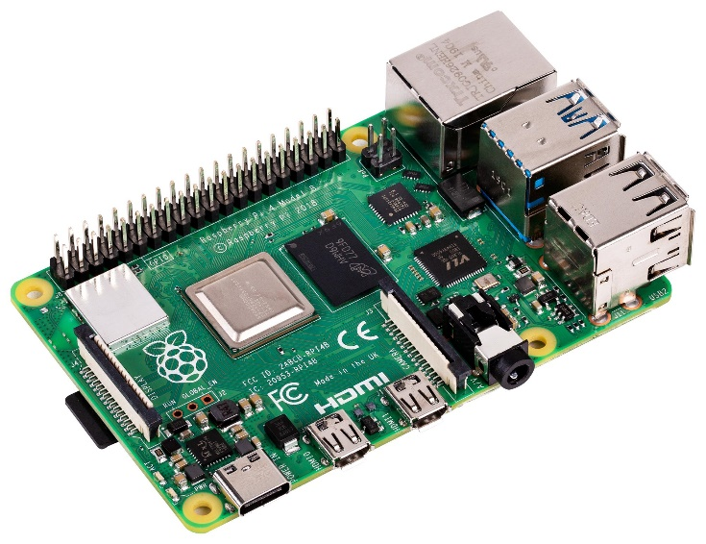

**Fig. Raspberry Pi 4 Model B**

In this project we are using Raspberry Pi 4 Model B as a Single Board Computer(SEB). The Raspberry Pi 4 Model B (RPI 4B) is a powerful, versatile single-board computer designed for a wide range of applications, from home automation to educational projects. It features a quad-core Cortex-A72 processor running at 1.5 GHz, offering significant performance improvements over its predecessors. The RPI 4B comes with multiple RAM options (2GB, 4GB, 8GB), dual 4K HDMI outputs, USB 3.0 ports, and Gigabit Ethernet, providing enhanced connectivity and multimedia capabilities. It supports dual-band Wi-Fi, Bluetooth 5.0, and has a 40-pin GPIO header for hardware interfacing. The RPI 4B is ideal for developers, hobbyists, and educators looking for a compact, low-cost computing solution.

* 1. **CAMERA**

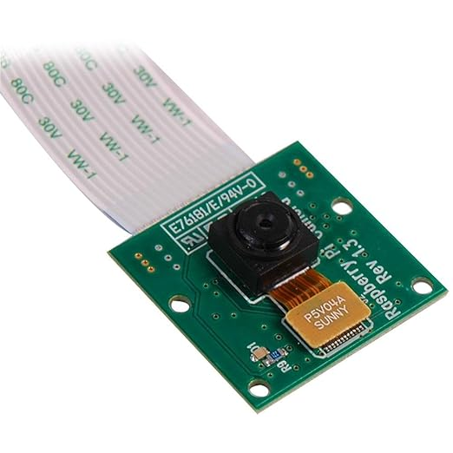

**Fig. Arducam**

The Arducam 1.3 is a versatile camera module designed for use with Raspberry Pi and Arduino boards. It features a 5-megapixel OV5647 sensor, providing high-quality images and video capture. The module is ideal for various projects, including surveillance, image processing, and robotics. With a compact form factor, it easily integrates into different systems. The Arducam 1.3 supports still images up to 2592x1944 resolution and video recording at 1080p, 720p, and 480p. It connects via the camera serial interface (CSI) and is compatible with popular software libraries, making it a reliable choice for DIY and professional applications.

* 1. **SENSORS USED**

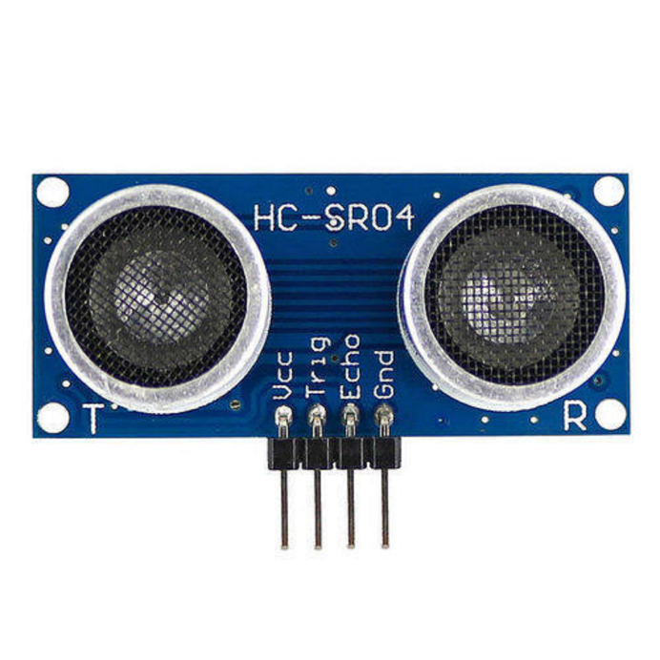

**Fig. Ultrasonic Sensor (HC-SR04)**

The HC-SR04 is a widely used ultrasonic sensor for measuring distance, ideal for robotics, obstacle detection, and automation projects. It works by emitting an ultrasonic pulse at 40 kHz through its trigger pin and then measuring the time it takes for the echo to return. The sensor calculates the distance to an object based on the time delay between the sent and received signals. It has a detection range of 2 cm to 400 cm with an accuracy of about 3 mm. The HC-SR04 is simple to interface with microcontrollers like Arduino and Raspberry Pi, making it popular for DIY electronics and robotics applications.

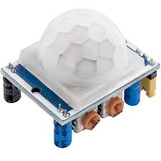

**Fig. Motion Sensor (HC-SR501)**

The HC-SR501 is a highly sensitive PIR (Passive Infrared) motion sensor widely used in security systems, lighting automation, and motion-activated devices. It detects infrared radiation emitted by moving objects, such as humans or animals, within its detection range of approximately 7 meters. The sensor features adjustable sensitivity and delay time, allowing customization for various applications. It operates on a wide voltage range (4.5V to 20V) and outputs a digital signal when motion is detected. The HC-SR501 is easy to integrate with microcontrollers like Arduino and Raspberry Pi, making it a popular choice for DIY home automation and security projects.

1. **OUTPUTS**
   1. **SCREEN**

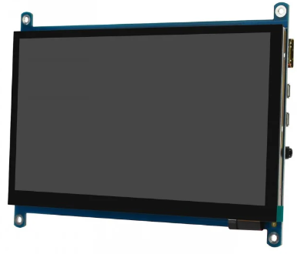

**Fig. Waveshare Screen**

The Waveshare screen is a versatile display module popular among developers and hobbyists for use with Raspberry Pi, Arduino, and other microcontrollers. Available in various sizes, from small 2-inch screens to larger 7-inch models, these screens offer clear, vibrant visuals with resolutions up to 1024x600. Some models feature capacitive or resistive touch functionality, enabling interactive projects. The Waveshare screen typically connects via HDMI, SPI, or GPIO, ensuring compatibility with a wide range of devices. It’s ideal for building portable monitors, custom interfaces, or embedded systems, offering a reliable and user-friendly display solution for various applications.

* 1. **SPEAKER**

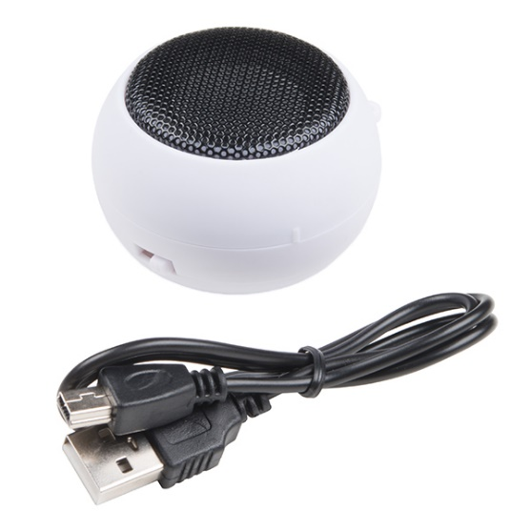

**Fig. Hamburger Speaker**

The Hamburger Speaker is a compact, portable Bluetooth-enabled speaker known for its unique, round design resembling a hamburger. Despite its small size, it delivers surprisingly clear and robust sound, making it ideal for on-the-go listening. The speaker easily connects to smartphones, tablets, and other Bluetooth devices, allowing wireless streaming of music, podcasts, or calls. It also features a built-in rechargeable battery, offering hours of playback on a single charge. Some models include a 3.5mm audio jack for wired connections and a microSD card slot for direct music playback. The Hamburger Speaker is a fun, convenient audio solution for personal use.

1. **FUNCTIONS**
   1. **Image Processing**

Image processing involves the manipulation and analysis of images to enhance their quality or extract useful information. In this code, image processing techniques such as adjusting brightness and contrast with cv2.addWeighted(), applying edge enhancement filters with cv2.filter2D(), and increasing color saturation through the increase_saturation() function are used to prepare the image for better analysis and detection. And we also use image saturation for helping people with Colour Blindness.

* 1. **Object Detection**

Object detection involves identifying and locating objects within an image, as demonstrated in the code using the YOLO (You Only Look Once) model. The findObject() function processes the image to detect objects, draw bounding boxes, and label them based on confidence levels. This is achieved using cv2.dnn.readNetFromDarknet() to load the YOLO model and cv2.dnn.blobFromImage() to prepare the image for detection.

To complement object detection with audio feedback, the speak() function utilizes the espeak utility to convert text into spoken words. After detecting objects, the function speak(text) is called to announce the names of the detected objects audibly. This integration ensures that users receive immediate auditory notifications about the presence of objects in the video feed, enhancing situational awareness.

* 1. **Real-Time Video Capturing**

Real-time video capturing involves continuously capturing and processing video frames as they are captured. In the provided code, the Picamera2 library is used to capture video frames from a camera. The picam2.capture_array() function captures the frame, which is then processed in real-time for object detection and displayed using cv2.imshow(). This enables live monitoring and immediate response based on the processed video feed.

1. **TEST CASES**

**5.1 FOR PARTIALLY BLIND INDIVIDUALS:**

Percepto Sphere’s features can be changed for *partially blind* individuals to enhance vision by utilizing advanced technologies to sharpen image and video quality. Here is how:

1. **Contrast and Brightness Adjustment:** The contrast and brightness can be enhanced, making it easier to distinguish objects, especially in low-light or overly bright environments.
2. **Edge Detection:** Software algorithms can emphasize edges and contours of objects, helping users identify shapes and navigate more easily.
3. **Magnification:** The glasses can allow users to zoom in on specific objects or areas, making small details larger and more visible.
4. **User Customization:** Users can personalize settings according to their vision needs, such as increasing contrast, adjusting colours, or zooming into specific areas.

**5.2 FOR COLOUR BLIND INDIVIDUALS:**

**Colour Filtering and Enhancement:**

1. **Selective Colour Filtering:** The glasses can use advanced filters to enhance the contrast between colours that are often difficult for colourblind individuals to distinguish. For example, they might boost the difference between red and green for someone with red-green colour blindness.
2. **Real-Time Colour Adjustment:** The glasses can dynamically adjust colours in real-time, modifying hues to make them more distinguishable. This adjustment can be customized based on the specific type of colour blindness the user has (e.g., deuteranopia, protanopia, tritanopia).

**Colour Substitution:**

1. **Hue Shifting:** The glasses can shift problematic colours into a spectrum that the user can see more clearly. For example, if a user cannot perceive red, the glasses might shift red hues towards a shade they can see, such as orange or yellow.
2. **Contrast Enhancement:** By enhancing the contrast between colours that are hard to differentiate, the glasses make it easier for the user to see the difference between them, which is especially useful in situations like reading color-coded maps or graphs.

**Personalized Colour Profiles:**

**Customized Settings:** The glasses can allow users to create and switch between different colour profiles tailored to specific environments or tasks, such as outdoor activities, reading, or using digital screens. These profiles can be adjusted based on the individual’s unique colour vision needs.

**Visual Cues and Overlays:**

1. **Pattern Overlays:** To aid in distinguishing between similar colours, the glasses can add subtle patterns or textures to specific colours, making it easier to differentiate them by more than just colour alone.
2. **Colour Labels:** In situations where colour alone is insufficient, the glasses can provide visual or auditory cues, such as labelling colours with text or sound, to assist the user in identifying them accurately.

**Adaptive Technology:**

1. **Real-Time Environment Adaptation:** The glasses can be tweaked to adjust to different lighting conditions and environments, ensuring that colour correction remains effective whether the user is indoors, outdoors, in bright sunlight, or in dim light.
2. **Context-Specific Enhancements:** Depending on the context (e.g., reading, driving, or cooking), the glasses can prioritize certain colours or enhance specific aspects of vision to aid in those particular activities.